**Issue No: 1**

**Issue: Kindly change the purchase group for the attached PO's as the old purchase group doesn't exist ASAP From: B27 (Old) To C56 (New)**

**Details:**

**Issue IMG:**

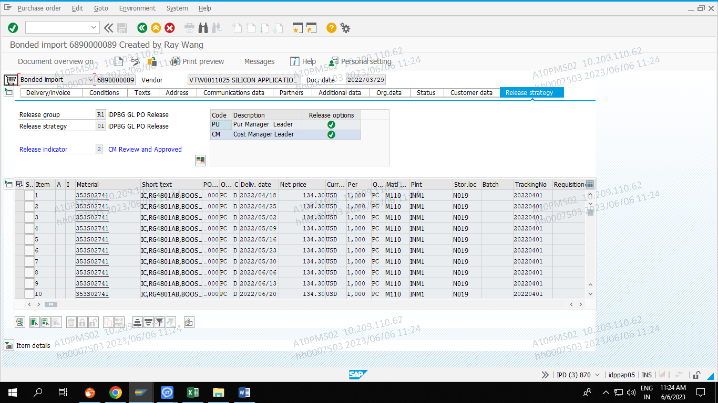

**Conclusion:**

**You see in release strategy tab, in release options you see two green tick icon. If you see two tick means not able to change SAP side.**

**Issue NO: 14**

**Issue: We have created PO for #152S01255B in the T.Code ZDPMM039. It will create PO QTY 720kpc But not showing in ZDPMM092 ME22N**

**Details:**

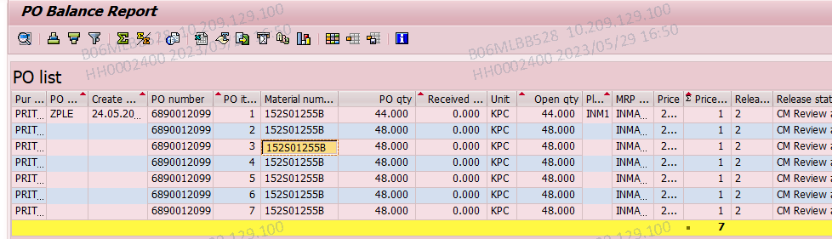

**PO:**

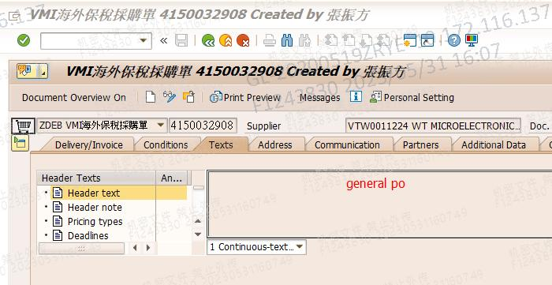

**MRP PO:**

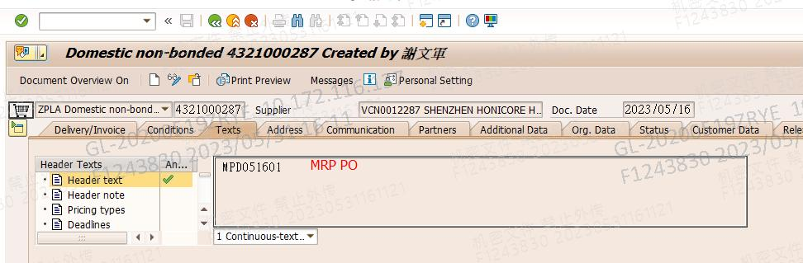

**Conclusion:**

**In this issue PO number 6890012099 and in this material number 152S01255B have a 332 QTY only stored in DB, So user get only 332 QTY only.**

**Issue NO: 20**

**Issue: Need to close test WO order auto close logic in SAP after 30days. WO type is FW8T, FN8T**

**Details:**

**Conclusion:**

**This auto close logic is not possible. There is one T.Code ZDPPP073 is manual close WO but user not have an access to use this but have an permission to use COHV.**

**Issue NO: 21**

**Issue: PO line item mismatch against PDF**

**Details:**

**Issue image**

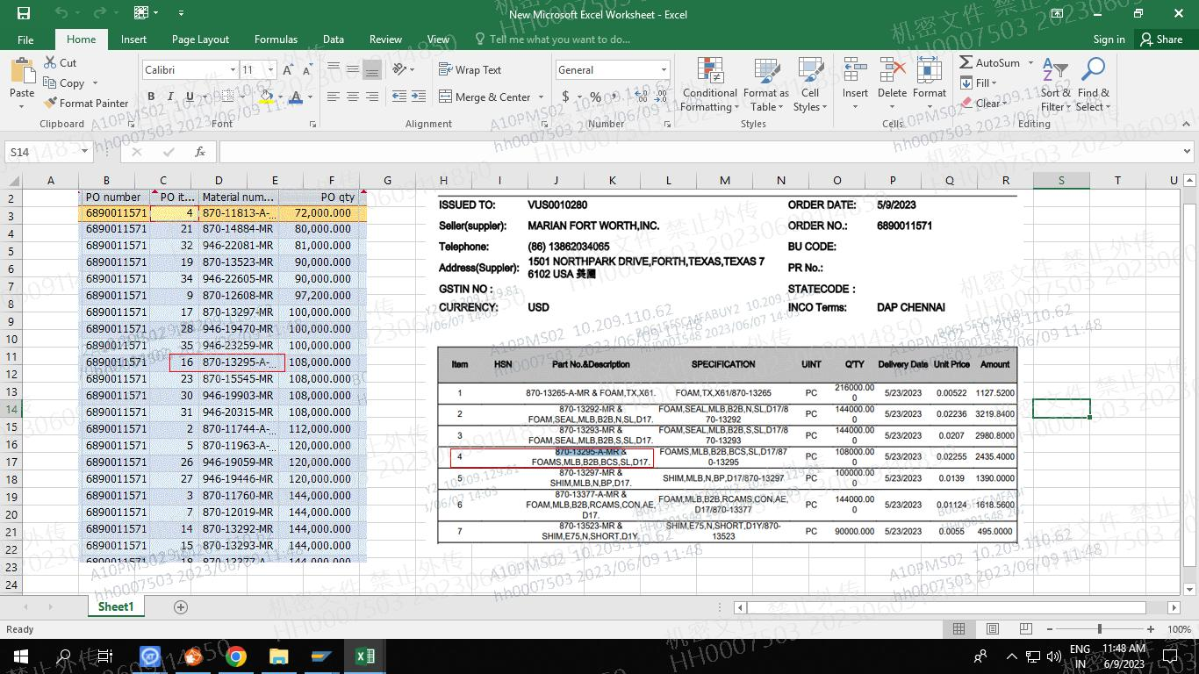

**Conclusion:**

**In SAP ME23N PO line item is correct but in ESIP download PO line item is changed. So, it is ESIP team issue.**

**Issue NO: 23**

**Issue: FG document create not working. There is an another way to create FG document using excel but direct process is ZDPMM130 this T.Code.**

**Details:**

**Input screen:**

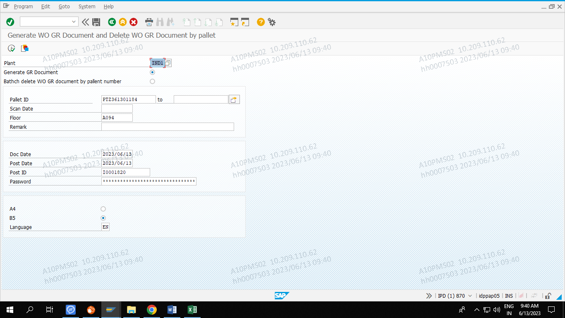

**Not getting any output.**

**Display WO: ZDPPP087**

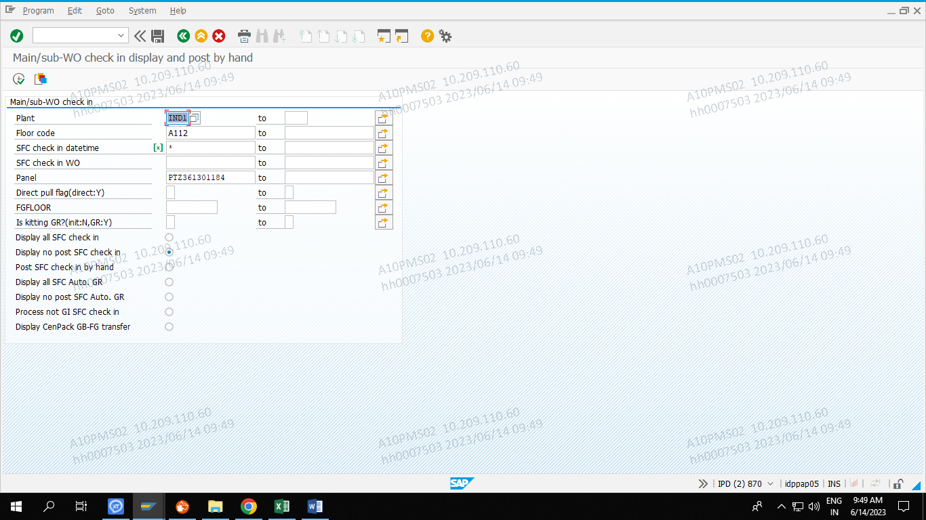

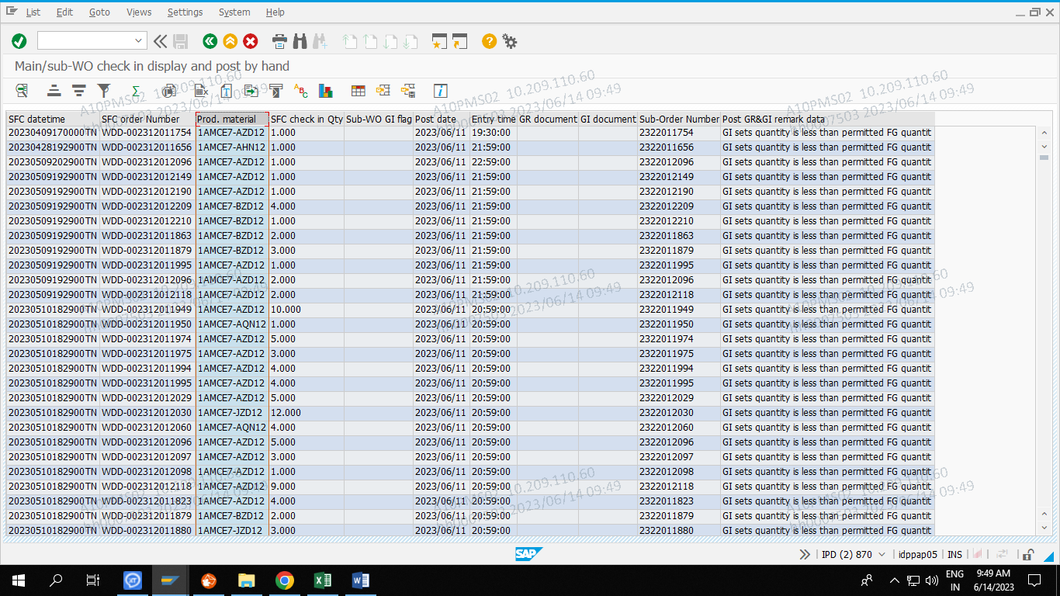

**Add storage locations: MMSC**

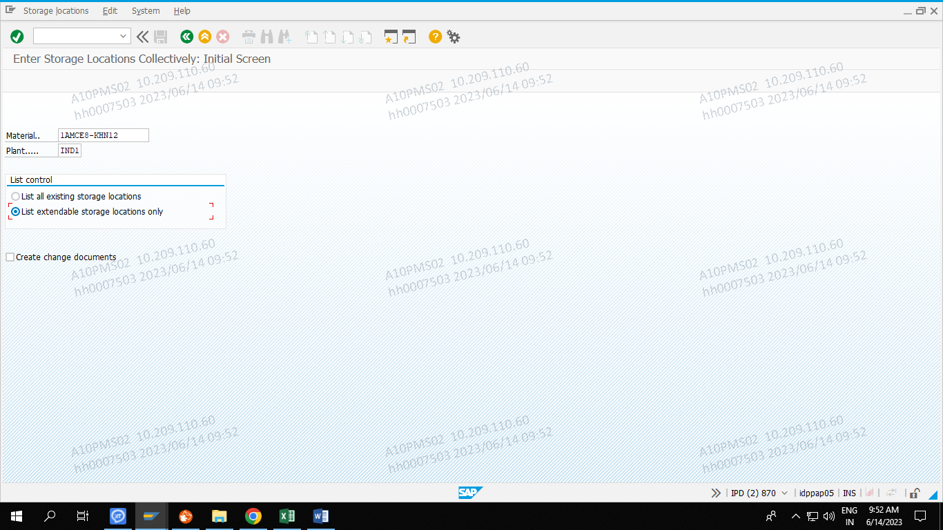

**Conclusion:**

**In MMSC T.Code I have added all material NO. D12U storage locations.**